C++ for Loop

Loops are used in programming to repeat a specific block until some end condition is met. There are three type of loops in C++ programming:

1. for loop
2. while loop
3. do...while loop

**C++ for Loop Syntax**

for(initializationStatement; testExpression; updateStatement) {

// codes

}

where, only testExpression is mandatory.

**How for loop works?**

1. The initialization statement is executed only once at the beginning.
2. Then, the test expression is evaluated.
3. If the test expression is false, for loop is terminated. But if the test expression is true, codes inside body of for loop is executed and update expression is updated.
4. Again, the test expression is evaluated and this process repeats until the test expression is false.

**Flowchart of for Loop in C++**

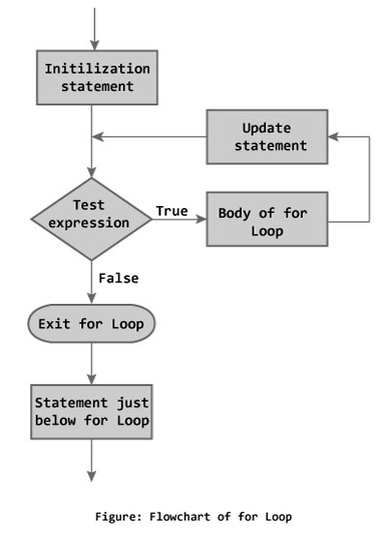

**Example 1: C++ for Loop**

// C++ Program to find factorial of a number

// Factorial on n = 1*2*3*...*n

#include <iostream>

using namespace std;

int main()

{

int i, n, factorial = 1;

cout << "Enter a positive integer: ";

for (i = 1; i <= n; ++i)

{

factorial *= i; // factorial = factorial * i;

}

cout<< "Factorial of "<<n<<" = "<<factorial;

return 0;

}

**Output**

Enter a positive integer: 5

Factorial of 5 = 120

In the program, user is asked to enter a positive integer which is stored in variable n (suppose user entered 5). Here is the working of for loop:

1. Initially, i is equal to 1, test expression is true, factorial becomes 1.
2. i is updated to 2, test expression is true, factorial becomes 2.
3. i is updated to 3, test expression is true, factorial becomes 6.
4. i is updated to 4, test expression is true, factorial becomes 24.
5. i is updated to 5, test expression is true, factorial becomes 120.
6. i is updated to 6, test expression is false, for loop is terminated.

In the above program, variable i is not used outside of the for loop. In such cases, it is better to declare the variable in for loop (at initialization statement).

#include <iostream>

using namespace std;

int main()

{

int n, factorial = 1;

cout << "Enter a positive integer: ";

cin >> n;

for (int i = 1; i <= n; ++i) {

factorial *= i; // factorial = factorial * i;

}

cout<< "Factorial of "<<n<<" = "<<factorial;

}